1) About your company/brand
- I am an independent education consultant passionate about helping students and parents navigate tertiary education pathways around the world with clarity and confidence. Choosing a university and career path is one of the biggest decisions a student will make, and my goal is to simplify the process so they can make informed decisions instead of feeling overwhelmed by fear or confusion.
- I believe every student has unique gifts, strengths, and potential. Rather than simply helping students gain admission to a university, I guide them towards programmes and institutions that align with their passions, abilities, and long-term goals, enabling them to build a fulfilling and meaningful future.
2) What services you provide
Provide end-to-end education consulting services, including:
- Personalised consultations to understand each student's academic background, interests, strengths, and career aspirations.
- University and programme comparisons to identify the best-fit options.
- Country comparisons across Malaysia, Singapore, the United Kingdom, Ireland, Australia, New Zealand, the United States, Canada, Germany, Hungary, Spain, Switzerland, China, and South Korea.
- University application guidance, including entry requirement assessments and application submissions.
- Scholarship assessments and advice.
- Personal statement reviews.
- Student visa application support, including student health insurance arrangements where required.
- Accommodation assistance.
- Pre-departure briefings to help students prepare for studying overseas.

For Schools:
- Conduct school talks on higher education pathways after SPM and IGCSE.
- Arrange for university representatives to deliver talks and workshops.
- Organize university fairs to connect students with local and international institutions.
3) How’s the workflow(steps) to work with you

Initial Consultation
I begin by understanding the student's academic background, interests, career goals, preferred study destination, and budget.

University & Programme Selection
Based on the consultation, I recommend suitable universities and programmes and provide comparisons to help students make informed decisions.

Application Submission
Once the student has shortlisted their preferred universities, I guide them through preparing the required documents, review their application materials, and submit the applications.

Offer Management
I monitor the application progress, explain any offer conditions, and help students fulfil any outstanding requirements to secure an unconditional offer.

Offer Acceptance
After the student decides on their preferred university, I guide them through accepting the offer and completing any required tuition deposit payments.

Student Visa Application
Where a student visa is required, I provide personalised, one-on-one guidance throughout the entire application process, ensuring every document is prepared correctly and submitted with confidence.

Accommodation & Pre-Departure
Once the student's place is confirmed, I assist with accommodation arrangements (where needed) and provide a pre-departure briefing to help them transition smoothly into university life overseas.
4) Testimonial, awards

- Qualified Education Agent Counsellor (QEAC): Credential ID QEAC #14731
- Embed code for QEAC: <a href="https://www.icef.com/academy/courses/australia-education-agent-training-course-aeatc/" target="_blank" title="Education Agent Training Course (EATC)"><img src="https://www.icef.com/academy/wp-json/badge/v1/embed/a2abG000000usnJQAQ" alt="ICEF Academy Badge: QEAC #14731" /></a>

- Certified British Council UK knowledge trained counsellors

Testimonials

From Bernice Choong:
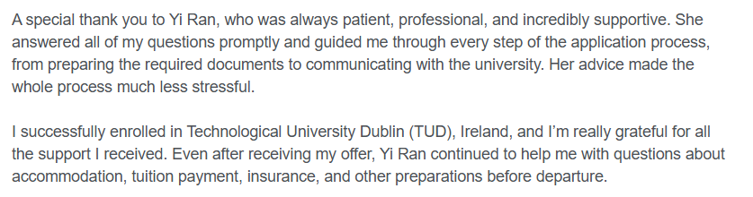

From Chu Eng Joe
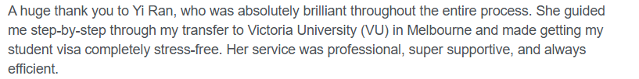

From Teo Xindian
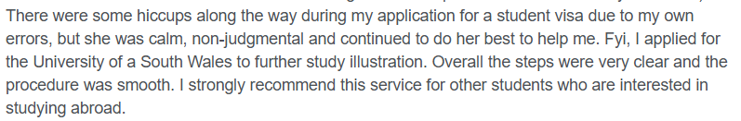

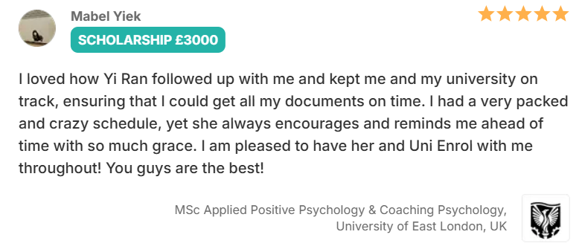
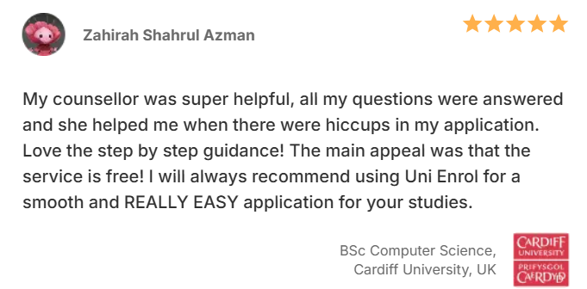

If you need more testimonies, I can ask my students to write for Gatekeeper too, these are the testimonials from previous students when I was working in my previous agencies.

5) Common questions people asked you and what is your answer
Here are some of the most common questions I receive from students and parents:
- What programme should I study?
- Which university is best for my chosen programme?
- What are the entry requirements?
- How much are the tuition fees?
- Are there any scholarships available?
- Is there an application fee?
- How long does it take to receive an offer?
- What documents do I need to prepare for my application?
- What are the career prospects after graduation?
- What is the pathway to becoming a doctor, lawyer, or architect?
- What documents are required for a student visa application?
- How much should I budget to study in Australia, the UK, or other countries?
- How do I accept my university offer?
- Can I work part-time while studying?
My answer is always tailored to each student's individual circumstances. There is no one-size-fits-all solution. I take the time to understand each student's academic background, interests, career aspirations, and financial situation before recommending the most suitable study options and guiding them through every step of the journey.

6) Your CTA
Contact me for a FREE consultation, including:
- Personalised course and university consultation
- Entry requirement assessment
- Scholarship assessment
- Study destination comparison
- University application guidance

7) Contact Info, Address.
- 0189016227 (this is my personal number)
- Address: TBC

Assets: Will provide later

1) Images
2) Videos

Access to your previous domain(can be later)

